You are given a positive integer n representing the number of nodes of a **Directed Acyclic Graph** (DAG). The nodes are numbered from 0 to n - 1 (**inclusive**).

You are also given a 2D integer array edges, where edges[i] = [fromi, toi] denotes that there is a **unidirectional** edge from fromi to toi in the graph.

Return *a list* answer*, where*answer[i]*is the****list of ancestors****of the* ith *node, sorted in****ascending order***.

A node u is an **ancestor** of another node v if u can reach v via a set of edges.

**Example 1:**

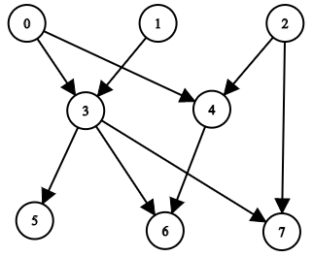

**Input:** n = 8, edgeList = [[0,3],[0,4],[1,3],[2,4],[2,7],[3,5],[3,6],[3,7],[4,6]]

**Output:** [[],[],[],[0,1],[0,2],[0,1,3],[0,1,2,3,4],[0,1,2,3]]

**Explanation:**

The above diagram represents the input graph.

- Nodes 0, 1, and 2 do not have any ancestors.

- Node 3 has two ancestors 0 and 1.

- Node 4 has two ancestors 0 and 2.

- Node 5 has three ancestors 0, 1, and 3.

- Node 6 has five ancestors 0, 1, 2, 3, and 4.

- Node 7 has four ancestors 0, 1, 2, and 3.

**Example 2:**

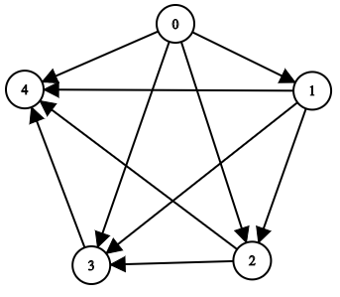

**Input:** n = 5, edgeList = [[0,1],[0,2],[0,3],[0,4],[1,2],[1,3],[1,4],[2,3],[2,4],[3,4]]

**Output:** [[],[0],[0,1],[0,1,2],[0,1,2,3]]

**Explanation:**

The above diagram represents the input graph.

- Node 0 does not have any ancestor.

- Node 1 has one ancestor 0.

- Node 2 has two ancestors 0 and 1.

- Node 3 has three ancestors 0, 1, and 2.

- Node 4 has four ancestors 0, 1, 2, and 3.

**Constraints:**

* 1 <= n <= 1000
* 0 <= edges.length <= min(2000, n * (n - 1) / 2)
* edges[i].length == 2
* 0 <= fromi, toi <= n - 1
* fromi != toi
* There are no duplicate edges.
* The graph is **directed** and **acyclic**.